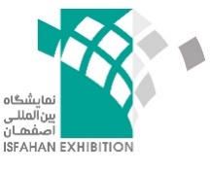 

**Specialized exhibition on Green Technologies & Clean Energy, 25-28 December, 2025, Isfahan, Iran**

Company Name:

...Address:

Country & City:

.. Fax: . Tel: Activity:

Director Manager Mobile:

Designation: .. Person in charge of the exhibition:

E-mail: .. .Web Site:

**Please specify your required area in the following table:**

|  |  |  |  |
| --- | --- | --- | --- |
| **Total Cost** | **Rental charge** | **Required Space** | **Type of Space** |
|  | 250 USD |  | Bare area |
|  | 300 USD |  | Standard stand |

*Standard stand includes of: Surrounding walls, 1 Table, 2 Chairs, Fascia, Floor covering, Spotlights and Electricity outlet for each 12 sqm.

**Terms of payment:**

100% of the participation charges should be paid and its receipt be sent together with the completed Registration Form to the organizer.

**With this contract we are accepting all the General Terms & Conditions of the exhibition and confirm our participation in GREENEX 2025.**

**Company Stamp Place/Date Legally binding Name & Signature**